**Train a time-series forecasting model using Automated Machine Learning**

Lab Overview

In this lab you will learn how the Automated Machine Learning capability in Azure Machine Learning (AML) can be used for the life cycle management of the manufactured vehicles and how AML helps in creation of better vehicle maintenance plans. To accomplish this, you will train a Linear Regression model to predict the number of days until battery failure using Automated Machine Learning available in AML studio.

Exercise 1: Creating a model using automated machine learning

Task 1: Create an automated machine learning experiment using the Portal

1. In [Azure portal](https://portal.azure.com/), open the available machine learning workspace.
2. Select **Launch now** under the **Try the new Azure Machine Learning studio** message.

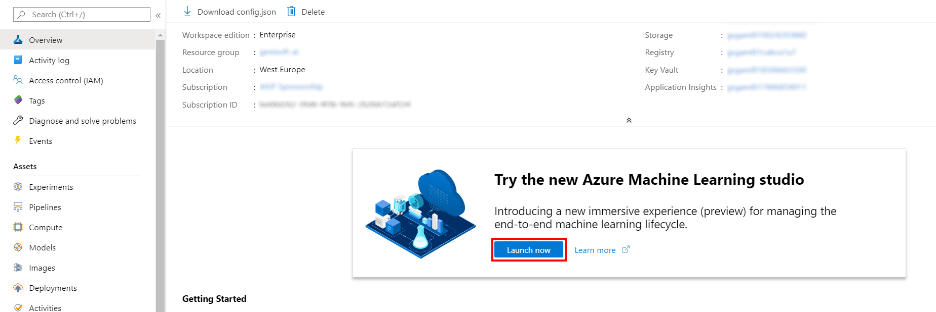

1. When you first launch the studio, you may need to set the directory and subscription. If so, you will see this screen:

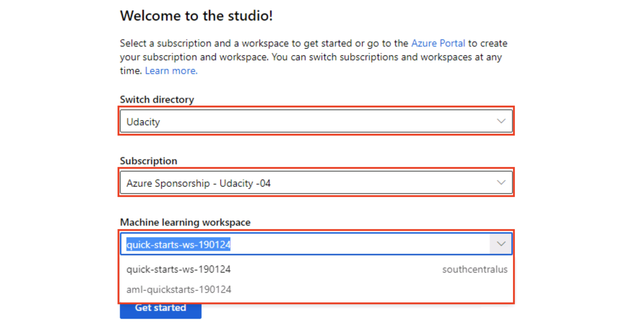

For the directory, select **Udacity** and for the subscription, select **Azure Sponsorship**. For the machine learning workspace, you may see multiple options listed. **Select any of these** (it doesn’t matter which) and then click **Get started**.

1. Select **Automated ML** in the left navigation bar.

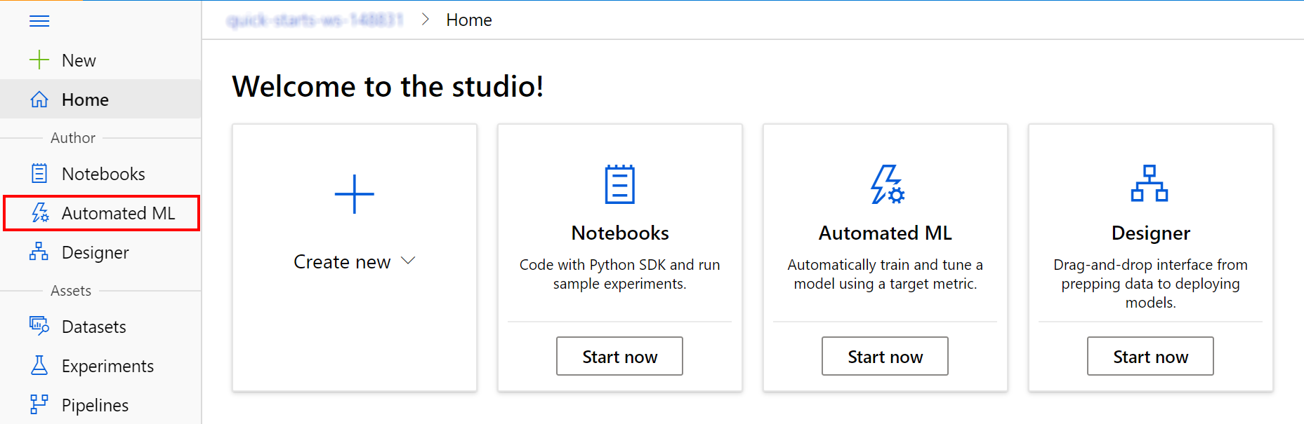

1. Select **New automated ML run** to start creating a new experiment.

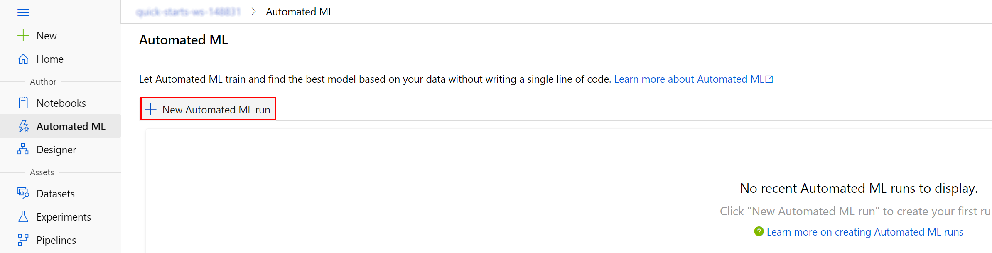

1. Select **Create dataset** and choose the **From web files** option from the drop-down.

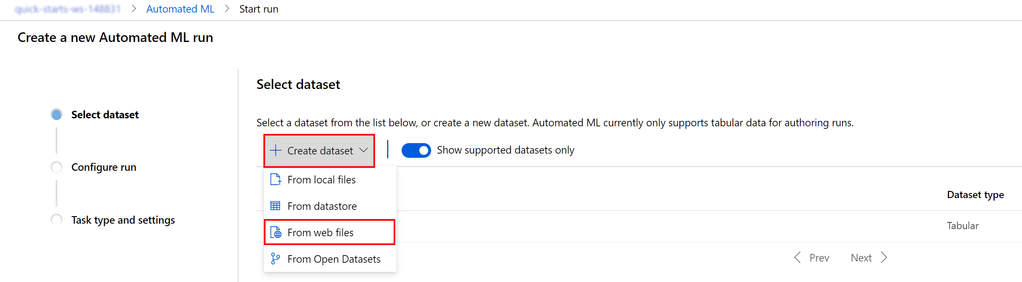

1. Fill in the training data URL in the Web URL field: https://introtomlsampledata.blob.core.windows.net/data/battery-lifetime/training-formatted.csv, make sure the name is set to training-formatted-dataset, and select **Next** to load a preview of the parsed training data.

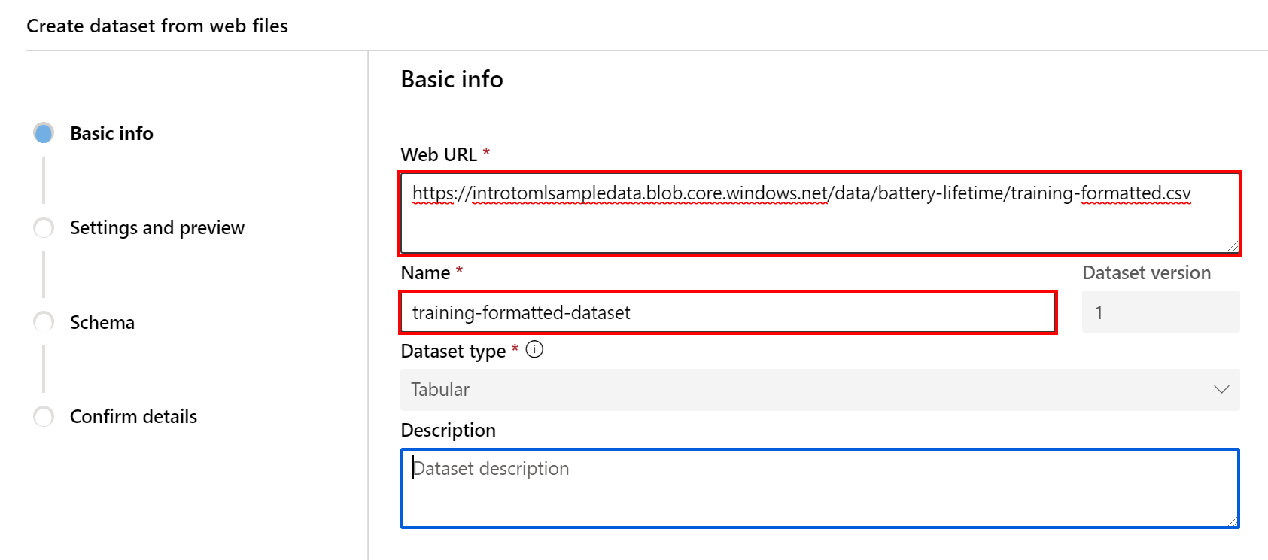

1. In the Settings and preview page, for the Column headers field, select All files have same headers. Scroll to the right to observe all of the columns in the data.

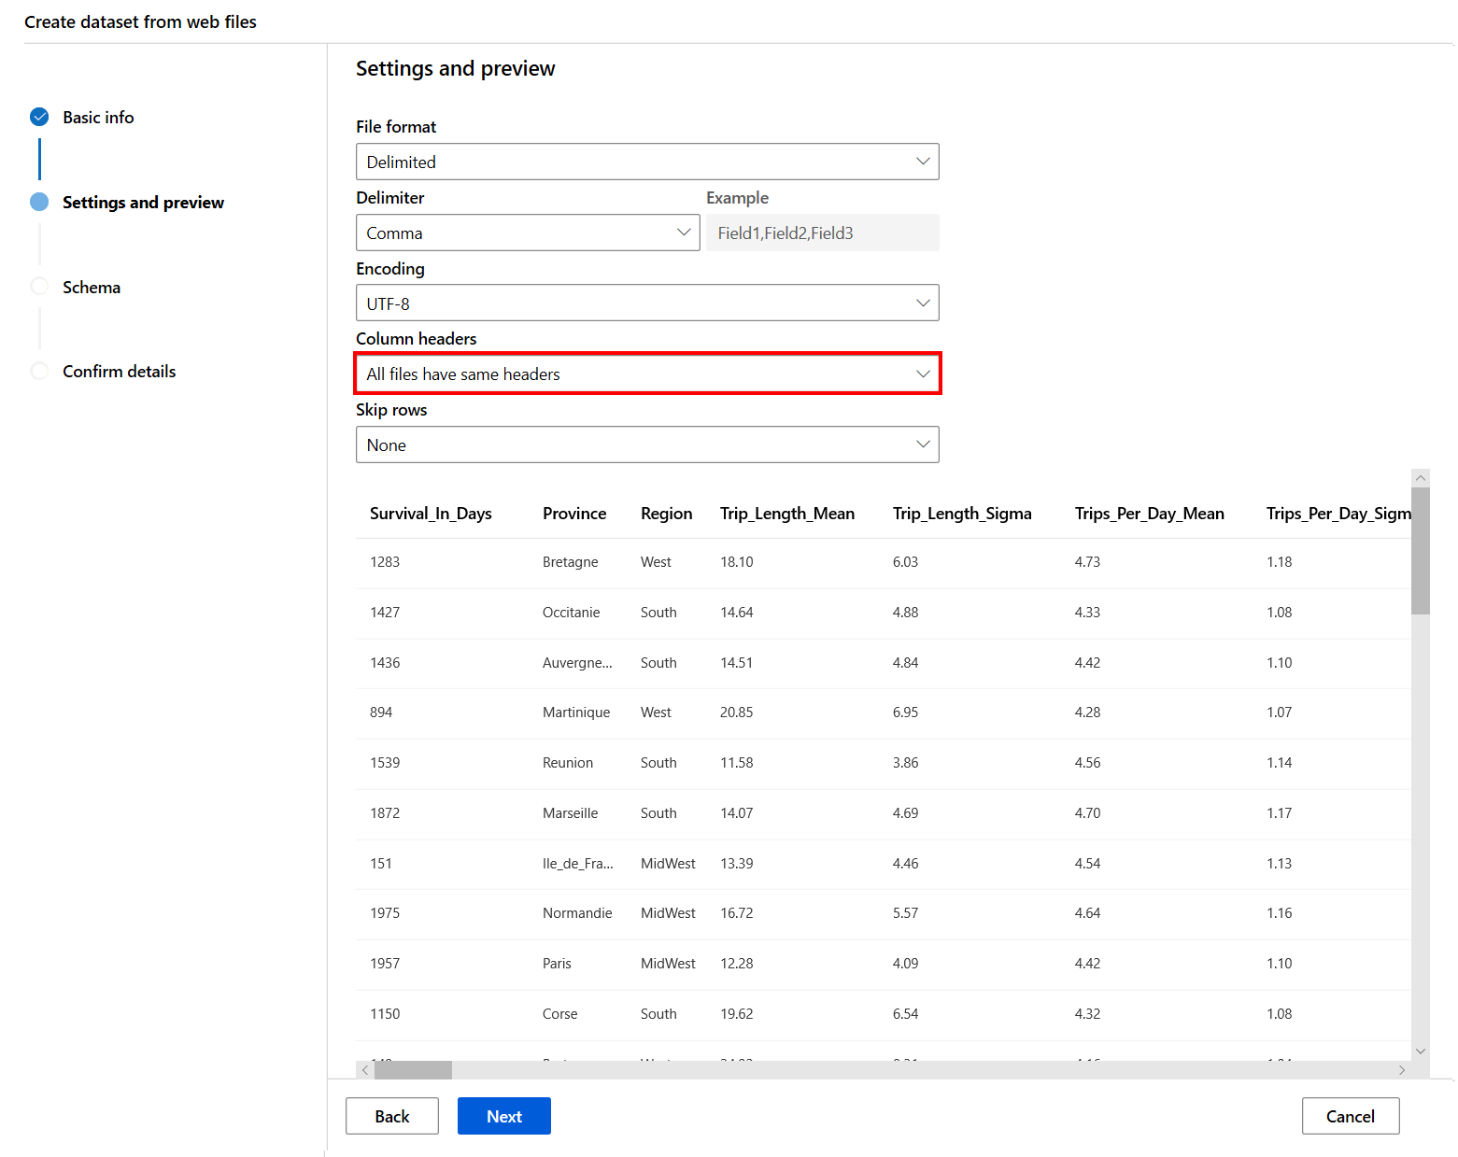

1. Select **Next** to check the schema and then confirm the dataset details by selecting **Next** and then **Create** on the confirmation page.

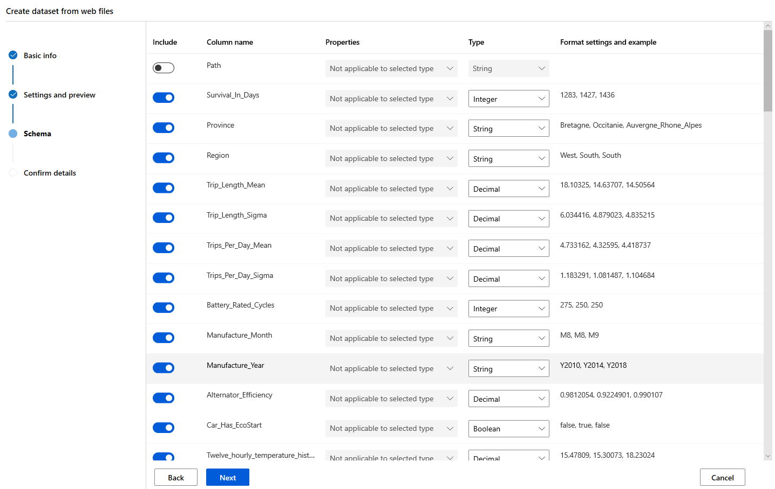

1. Now you should be able to select the newly created dataset for your experiment. Select the training-formatted-dataset dataset and select **Next** to move to the experiment run details page.

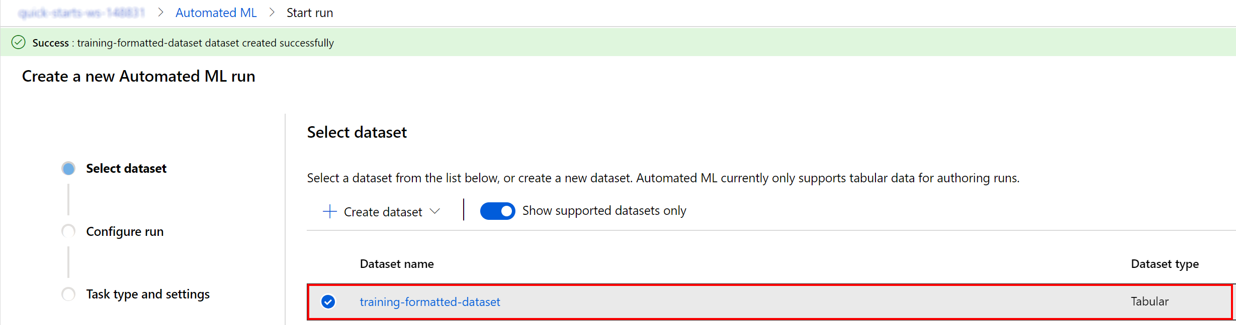

1. You will now configure the Auto ML run basic settings by providing the following values for the experiment name, target column and training compute:
   * Experiment name: **automlregression**
   * Target column: select **Survival_In_Days**
   * Select training compute target: : select **qs-compute**

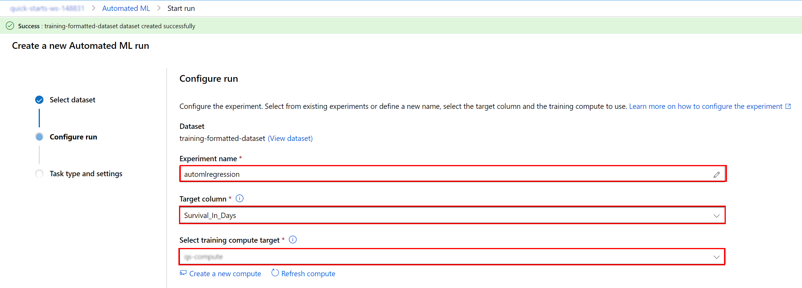

1. Select **Next** and select **Regression** in the Task type and settings page.

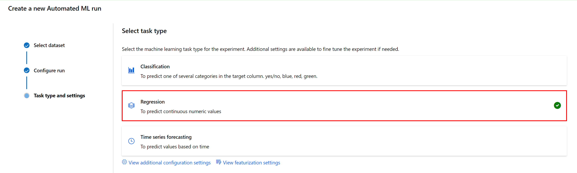

1. Select **View additional configuration settings** to open the advanced settings section. Provide the following settings:
   * Primary metric: **Normalized root mean squared error**
   * Exit criterion > Metric score threshold: **0.09**
   * Validation > Validation type: **k-fold cross validation**
   * Validation > Number of Cross Validations: **5**
   * Concurrency > Max concurrent iterations: **1**

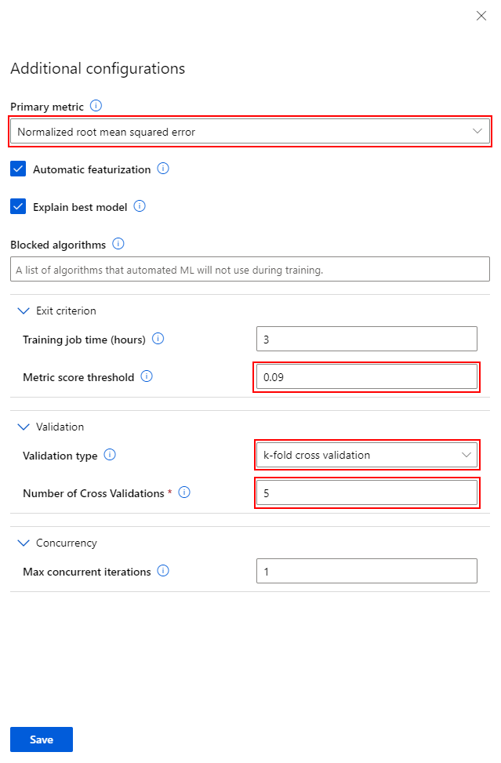

1. Select **Save** and then **Finish** to begin the automated machine learning process.

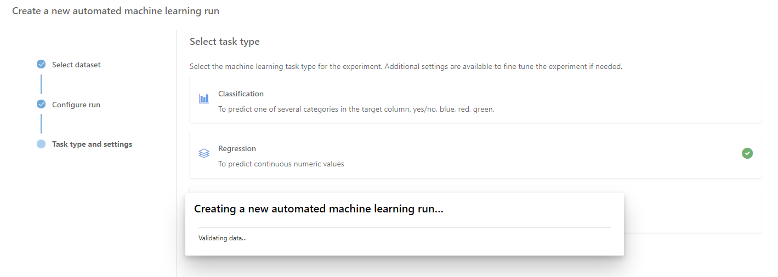

1. Wait until the Run status becomes **Running** in the Run Detail page.

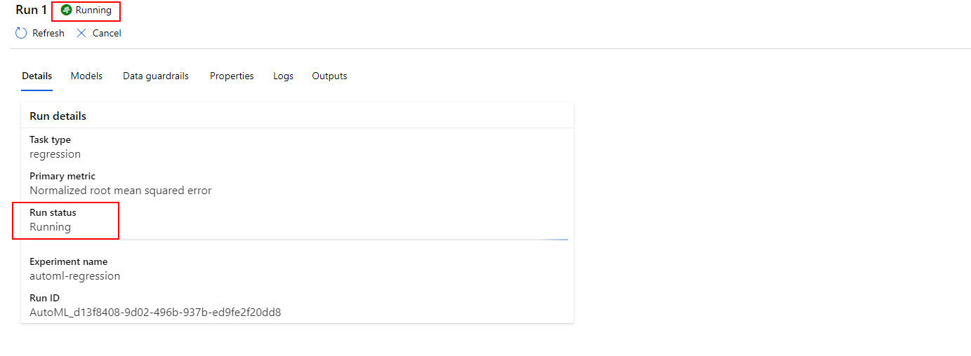

Task 2: Review the experiment run results

1. The experiment will run for about *15 minutes*. While it runs and once it completes, you should check the Models tab on the Run Detail page to observe the model performance for the primary metric for different runs.

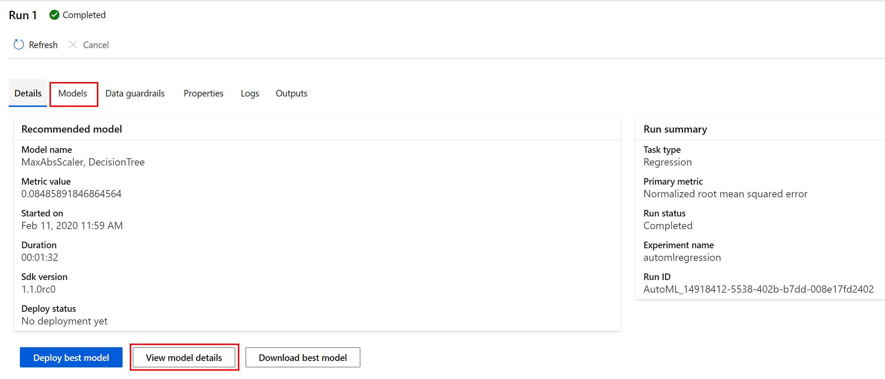

1. In the models list, notice at the top the iteration with the best **normalized root mean square error** score. Note that the normalized root mean square error measures the error between the predicted value and actual value. In this case, the model with the lowest normalized root mean square error is the best model.

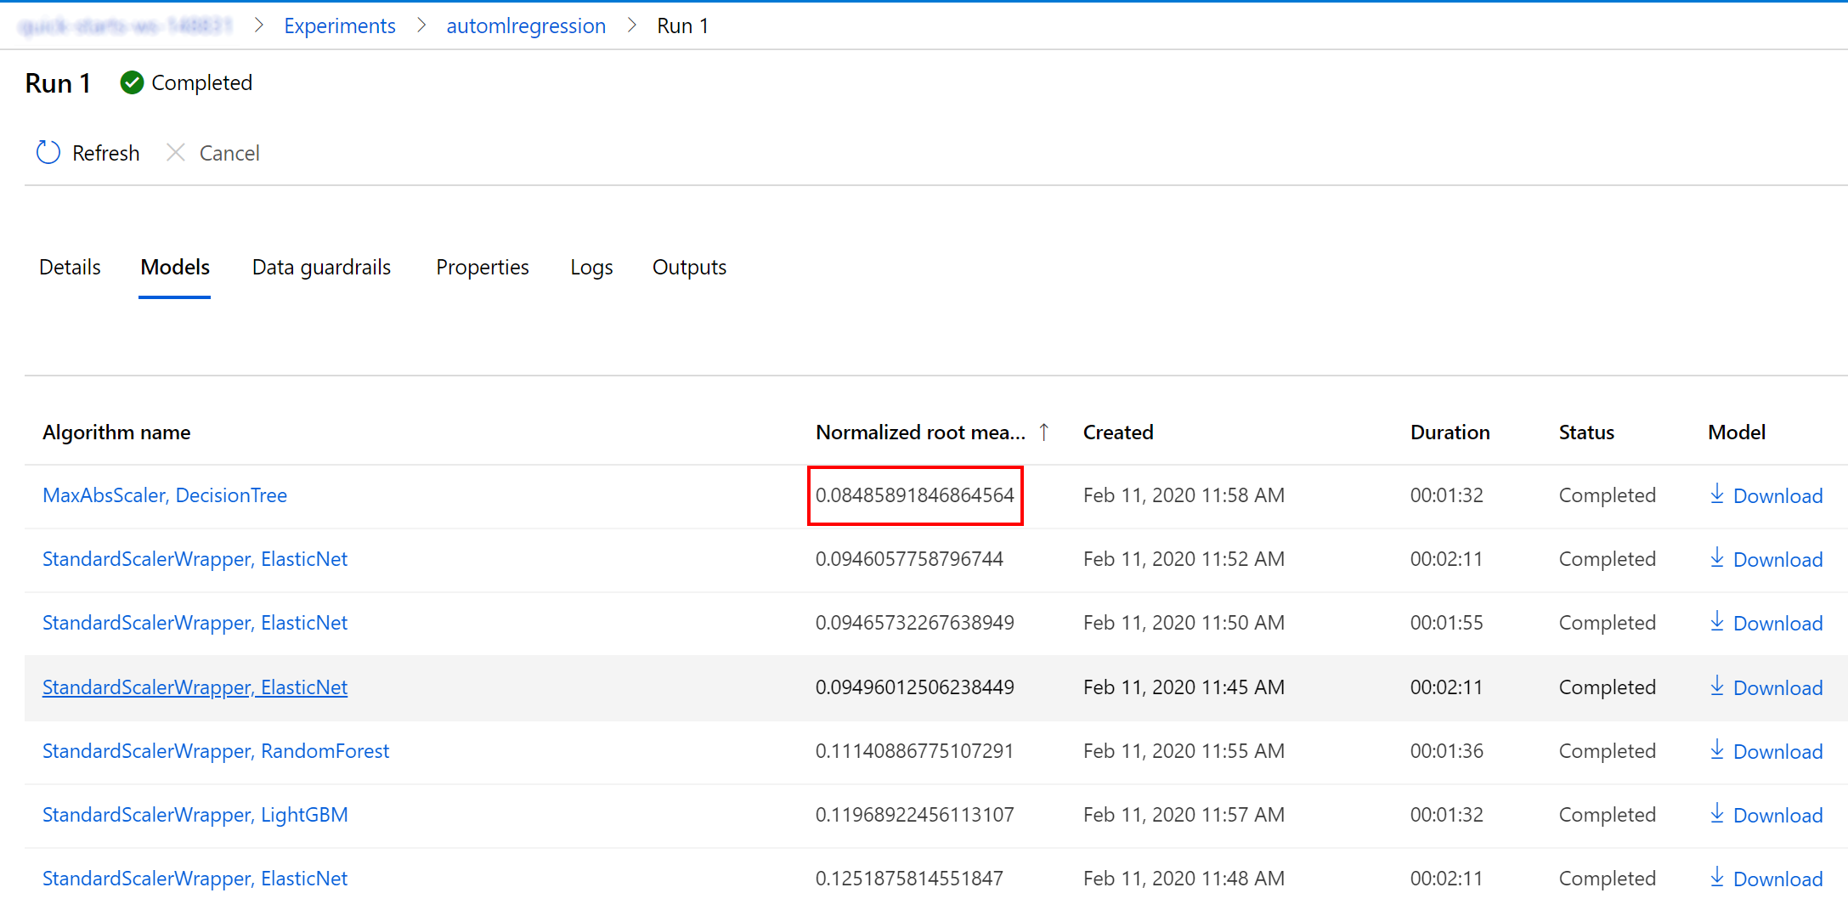

1. Select **Experiments** on the left navigation pane and select the experiment automlregression to see the list of available runs.

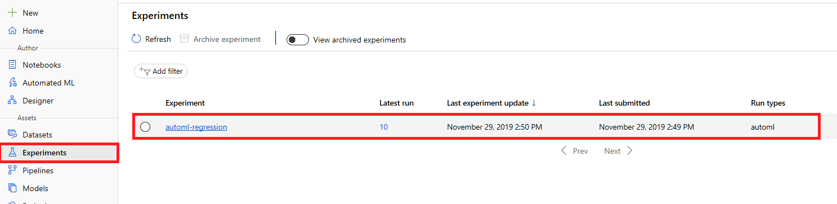

1. Select the option to **Include child runs** to be able to examine model performance for the primary metric of different runs. By default, the left chart describes the normalized_median_absolute_error value for each run. Select the pen icon on the right corner of the normalized_median_absolute_error chart to configure the normalized_root_mean_square_error metric representation.

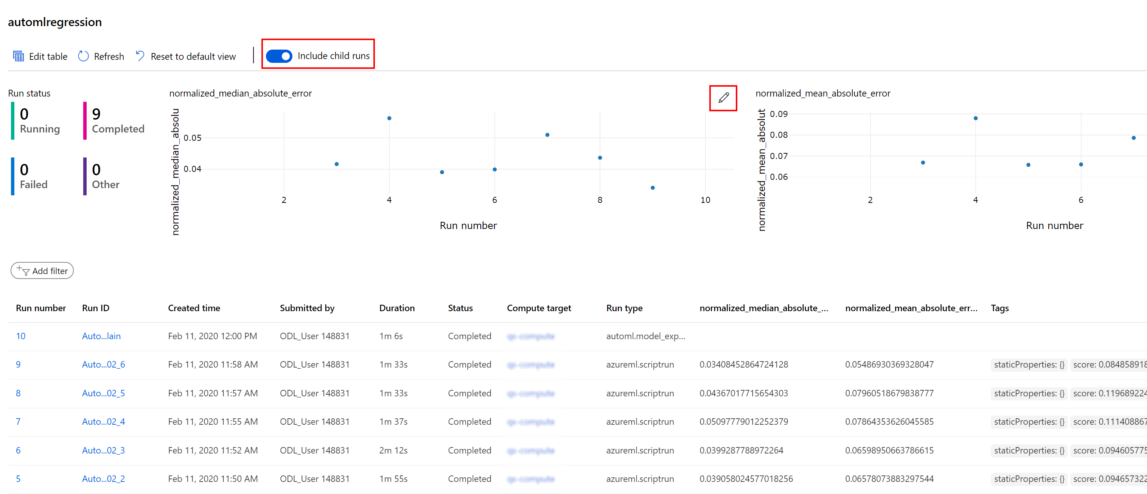

Next Steps

Congratulations! You have trained a simple time-series forecasting model using automated machine learning in the visual interface. You can continue to experiment in the environment but are free to close the lab environment tab and return to the Udacity portal to continue with the lesson.